On 17 May 2018 a very interesting visit was made to both the Lyceum and Crucible theatres. Although the visit coincided with rehearsals on the Lyceum stage and auditions on the Crucible stage, meaning that members could not ‘strut their stuff’, there was a lot to interest us.
We were told of the long struggle to restore The Lyceum to its original glory as an Edwardian theatre, the last one outside London designed by the famous theatre designer W. Sprague. The £12m restoration involved installing modern innovations (eg air conditioning, and much improved stage lighting) whilst being faithful to the original elaborate interior decoration, which was in a state or disrepair and in danger, in part at least, of being completely lost. The tour included a climb to the ‘Gods’ to allow the best possible view of the restored ceiling (see photo below), a magnificent sight.
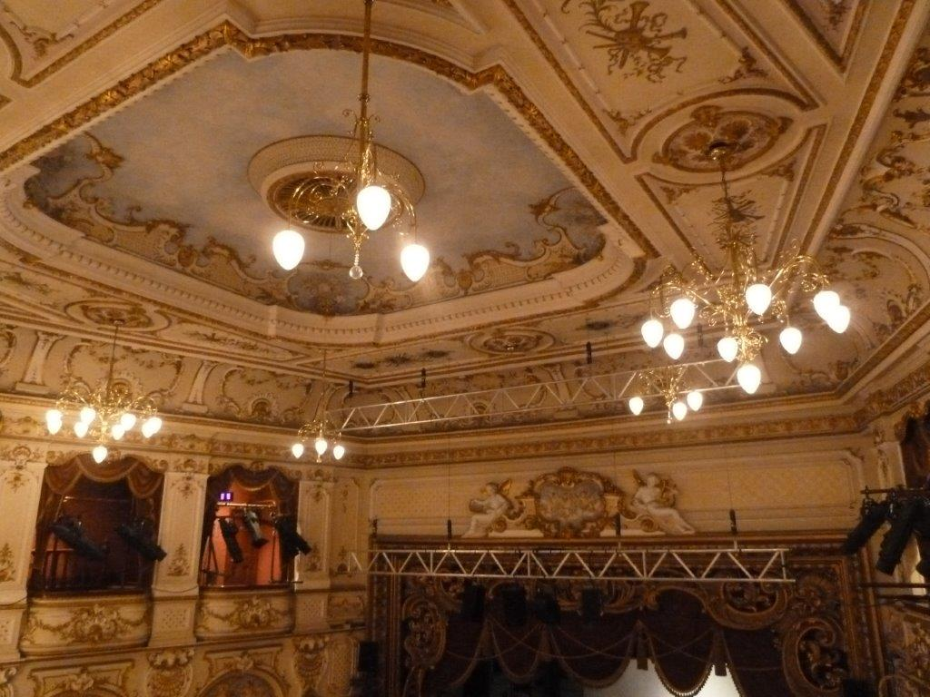
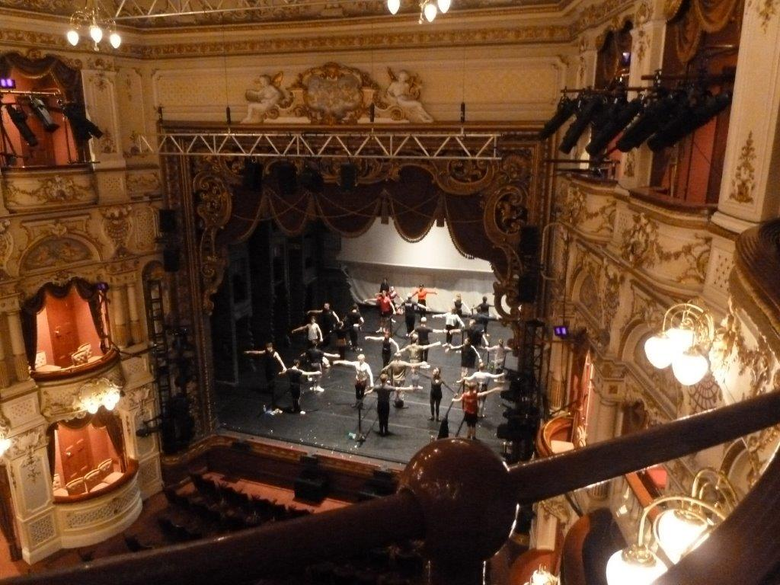
In addition, a visit to the understage dressing rooms and wardrobe department at the Crucible revealed the extensive collection of costumes, rack upon rack, and one or two costumes of interest were highlighted. These two pictures taken during the talk at The Lyceum illustrate the elegance of the restoration even in areas outside the main theatre. It was a fascinating visit.

