ANNUAL LUNCH, 26th MAY 2022, at Abbeydale Golf Club
Thirty-three members attended the Abbeydale Golf Club for the Annual Lunch, which has now been moved from October to May. It was organised, as ever, by Stuart Barlow with the assistance of Andrew Raftery and Richard Lowe , and as usual the organisation was excellent. The meal was without doubt a great success, enhanced by our Chairman giving the shortest speech on record! The profit of £150 from the raffle will be donated to the DEC Ukrainian Appeal.
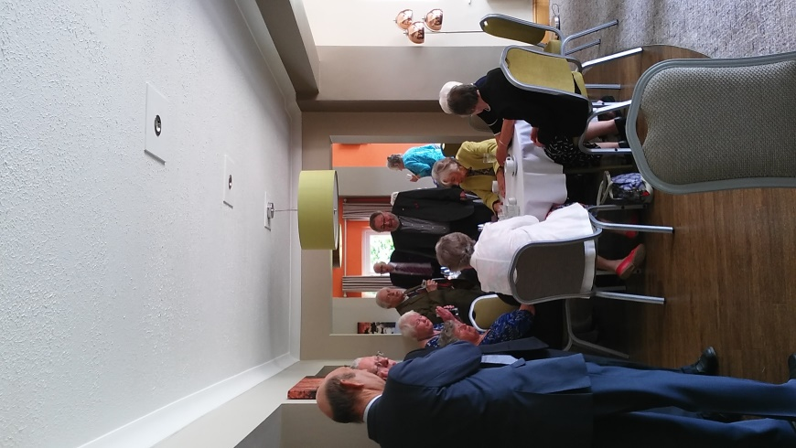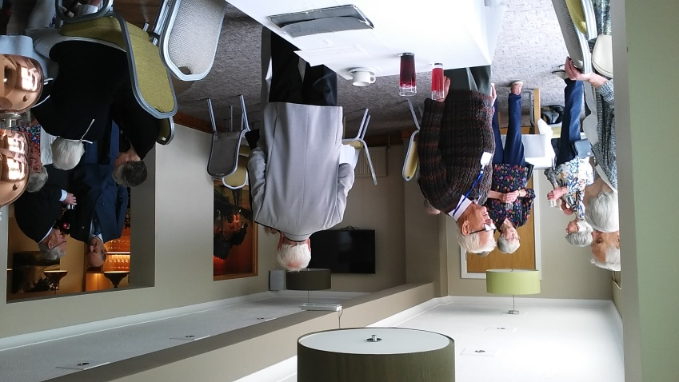

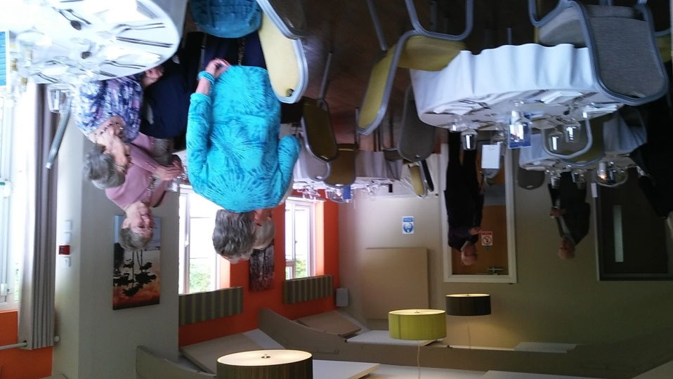

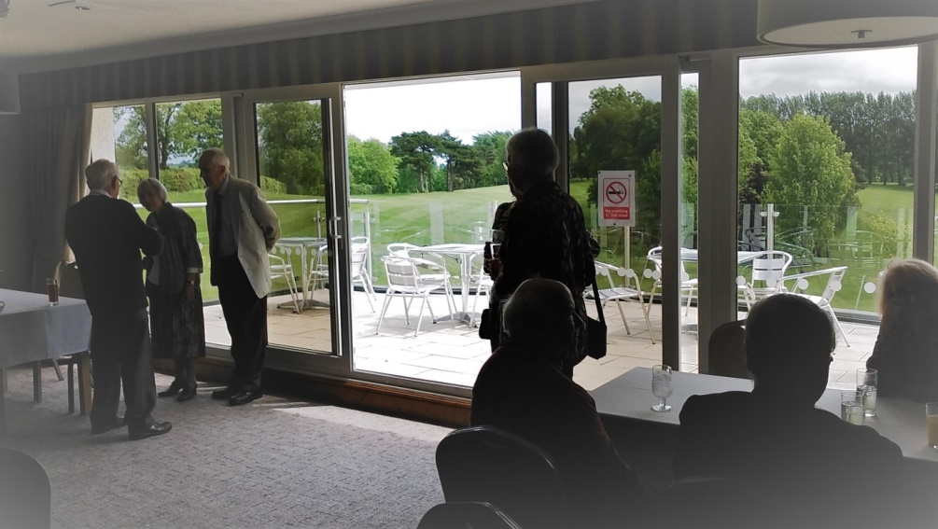

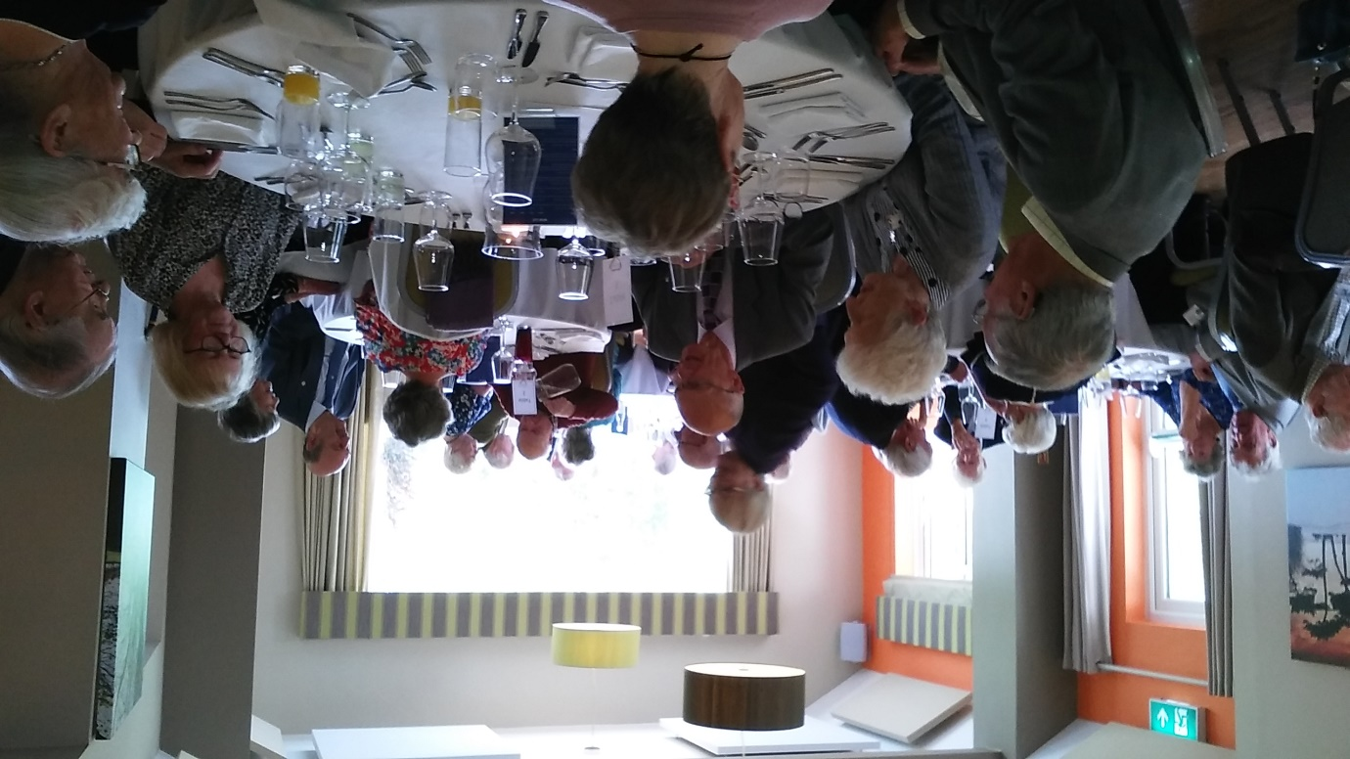

(Roger Emerson)

