VISIT TO ‘THE GREAT BRITISH CAR JOURNEY’, 27/04/22
NOSTALGIA: A yearning for past circumstances or events (Collins Concise Dictionary)

April 27th found a group of distinguished gentlemen and one lady assembled in the carpark of Holy Trinity Millhouses. At 10.15am precisely four loaded cars headed out for Ambergate , some choosing to go via the Motorway and some using the country route via Chatsworth and Matlock. Needless to say the car with Graham Hill arrived first!
Any onlooker would have been amused to see a group of “oldies” trying to suss out the workings of the audio aids that are included in the very reasonable entry price. However with the assistance of an Emeritus Professor of IT and one or two more knowledgeable members of the group we were all equipped for a most entertaining two hours or more.
The collection of one hundred plus British cars from 1902 to 2022 proved to be totally engrossing and provoked a never ending series of phrases such as:
- My dad used to drive one like that.
- I learned to drive in one of those
- I crashed in one like that
- That model is the first car I bought - for £95 2s 6p
- I had my first kiss with a girl in the back seat of one of them
- They were terrible going uphill
- I don’t think I ever finished a journey without a breakdown
- That is the car my wife and I had before the children arrived
- No way I could get into that. People must have been smaller in those days.
The air was thick with nostalgia.
If my garage in Pingle Road and my Bank Balance were large enough I would take home the beautiful light blue two seater Sunbeam Alpine, the seductive black Austin Healey 3000 and the smooth understated Bentley Continental. . .
I think we all particularly enjoyed the fellowship helped by the ambiance of this delightful visitor attraction. Recommended highly, not just for petrol heads but for anyone with an enquiring and sentimental mind.

Richard Lowe

The museum is a large warehouse-like building, divided into 9 ‘rooms’, each covering a decade, from pre 1930 to post 2000, and visitors are given a pre-recorded guide which has a general overview of each decade, and on which there is the facility to find a more detailed description of every car on display, all the posters and artwork on display, and more on the notable personalities of each period in car history. Therefore, one can be as superficial or as detailed as one would like.

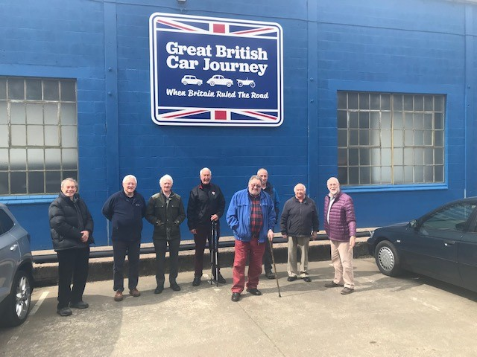

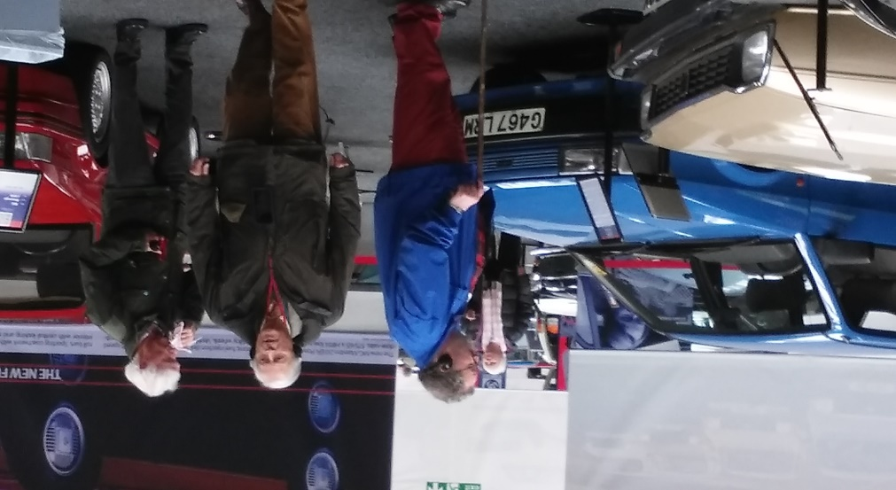

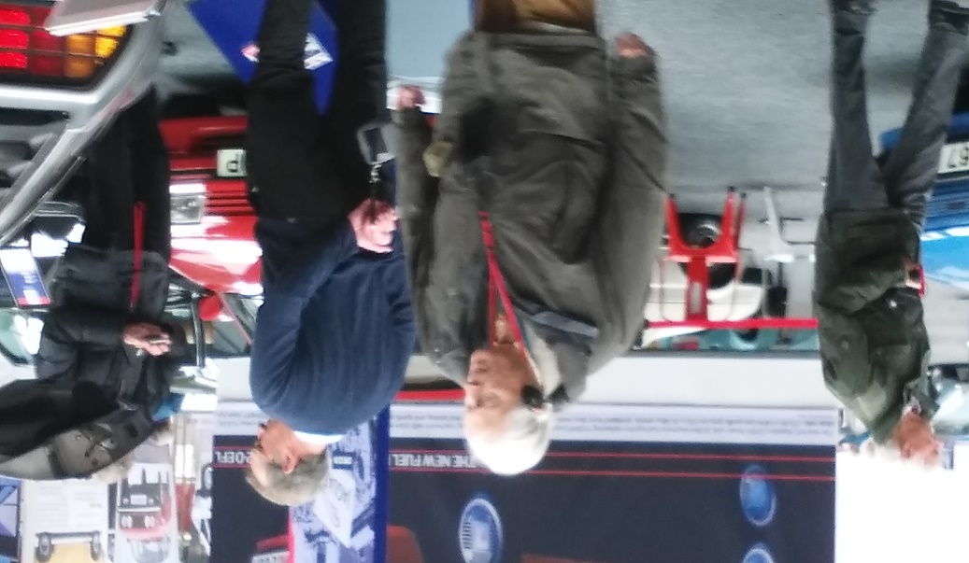
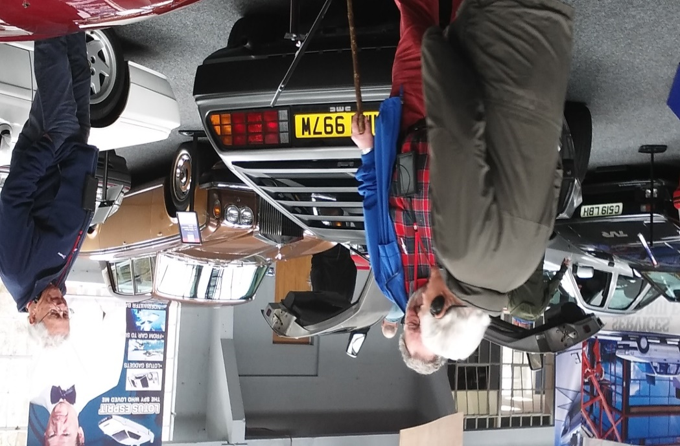

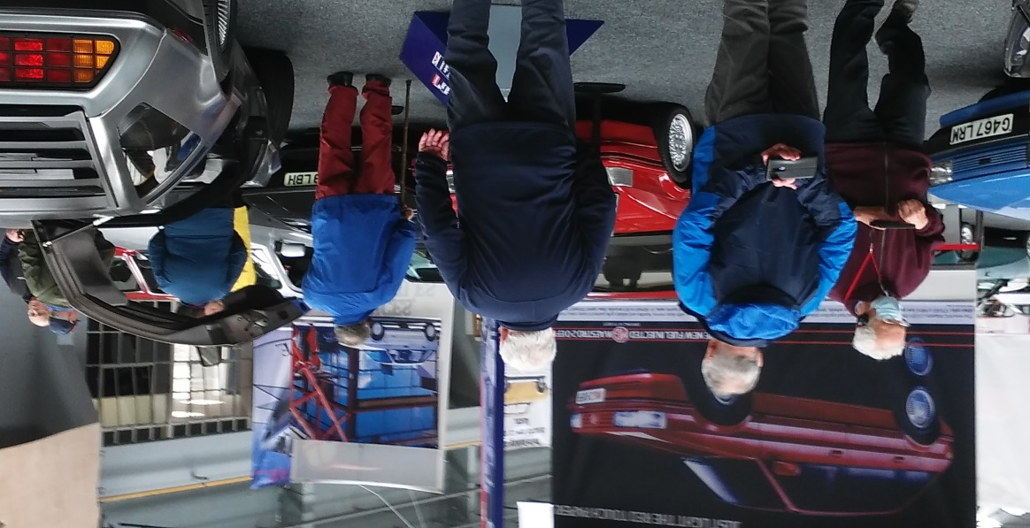

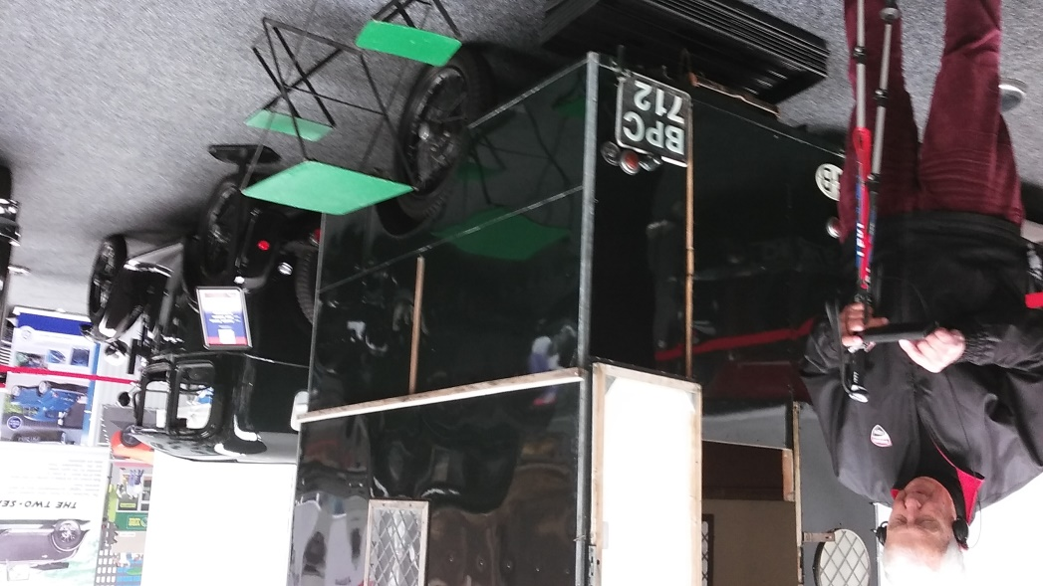
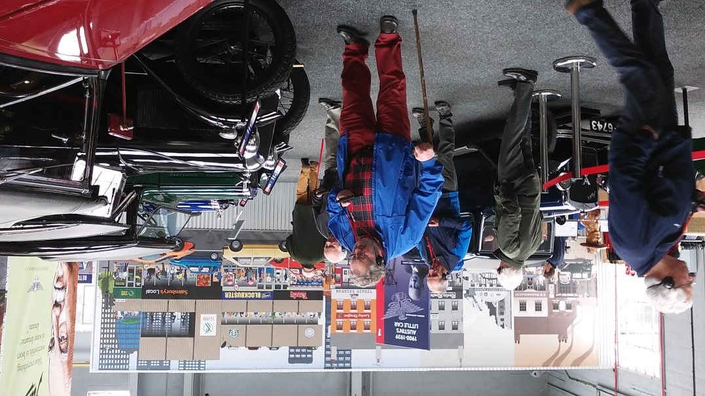

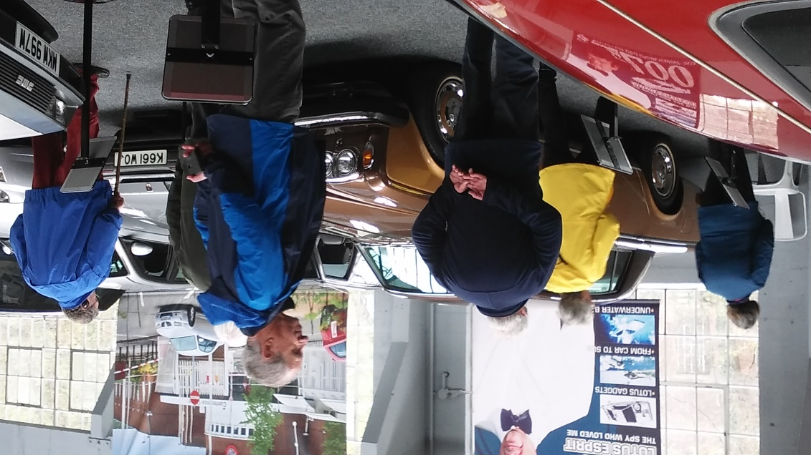

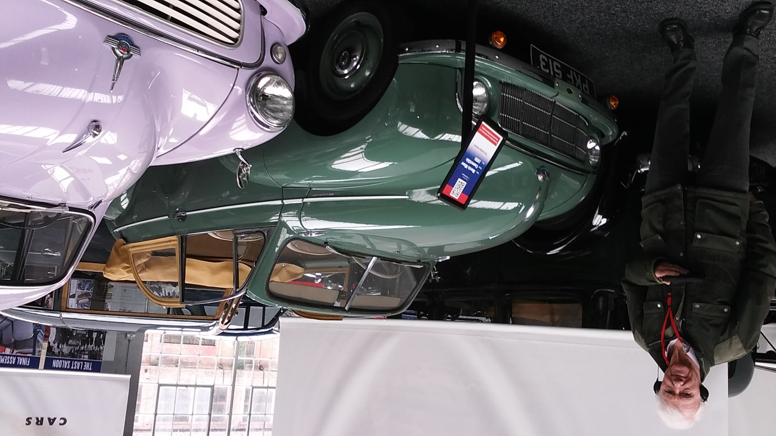

An excellent trip, and our thanks to Richard Lowe for organising it.

(Roger Emerson)

