ABBEYDALE ROAD HISTORIC BUILDINGS.
Over the years, for a variety of reasons, Sheffield has allowed many of its old, attractive buildings to suffer from neglect, some disappearing altogether. I will focus on some of the lost heritage in our area.
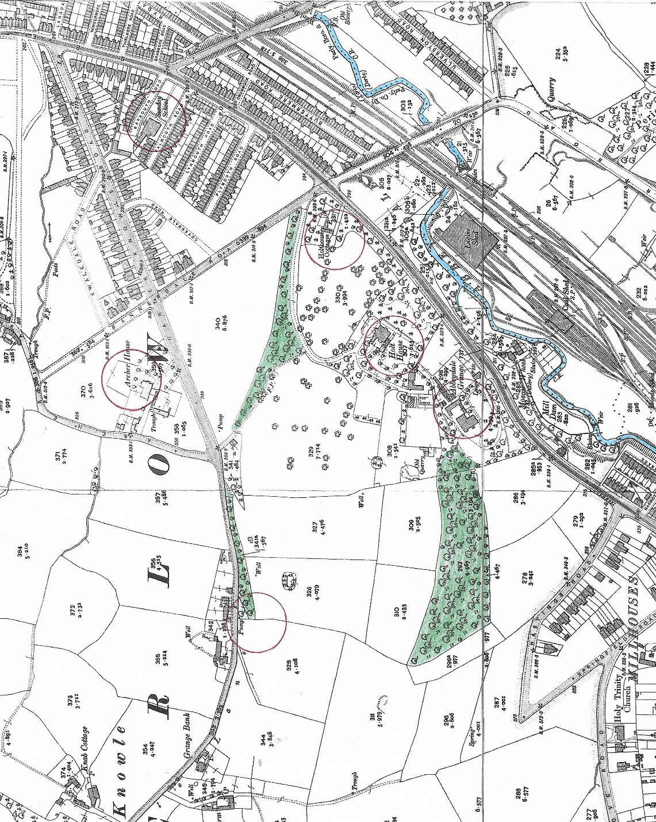
This 1903 OS map has circles round the buildings to be featured. They are: Abbeydale House (shown here marked Sunday School, opposite the bottom of Woodseats Road), Holt House, Abbeydale Grange and Archer House. The 1st three properties are situated by Abbeydale Road (which was a tramway in 1903), and Archer House is by Archer Lane. Holy Trinity Church (originally built in 1897), where our Probus Club meets, is bottom left, and the River Sheaf winds its way from bottom centre to right centre.
The 1st property to be covered is Abbeydale House which, although still standing and grade ll listed, is in a sorry state. I imagine that a lot people are unaware of its existence, even though they may drive or walk past it quite regularly.
It was a country house built in 1849 for John Rodgers, who was for 40 years head and driving force behind the most world-famous cutlery firm in Sheffield’s history, Joseph Rodgers & Sons. John, a son of Joseph Rodgers the founder, was a brilliant business man who devoted his life to the company. A visit to the works of Joseph Rodgers and Sons, especially to their showrooms (images in Part 2) which displayed the finest and most skilled pieces of workmanship, became a must for distinguished visitors to Sheffield, including royalty.
John followed the movement of other town manufacturers who were building country residences in the Abbeydale, Sharrow and Nether Edge areas. He had begun acquiring land during the 1830s, and by the time of his death had amassed a considerable estate, including land at Millhouses, Norton Hammer, Archer Lane and what became the Archer Road area. He moved to Abbeydale House from his old home, Hillsborough Hall, in 1850 and remained there until his death in 1859. His grave lies in Ecclesall churchyard.
John Rodgers’ nephew and successor in the family firm, Robert Newbould, built a house further along Abbeydale Road in 1851 and named it Abbeydale Grange.

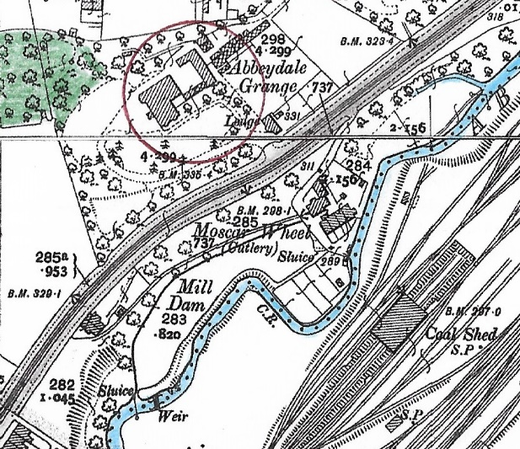
Moscar Wheel and its Mill Dam were on the River Sheaf, roughly where Tesco petrol station is now, on Abbeydale Road South. This is the oldest recorded cutlers’ wheel not only on the Sheaf but on any of Sheffield’s rivers. In 1496 the 2 wheels at the mill were rented to 2 “cuttelars” for 10 years. Between 1856 and 1891, when the mill stopped operating, the tenant was the cutlery firm of Joseph Rodgers & Sons.

Abbeydale Grange has totally disappeared and has been replaced by Windsor House retirement home, but the Lodge/Gate House still remains and can be seen opposite the Tesco petrol station on Abbeydale Road South.
Most of the Abbeydale House estate was sold in 1860 after John Rodger’s death to John Firth of Thomas Firth and Sons, the great steel-making company. Thomas Firth built himself a house on part of the estate on the site of a farm called Holt House, dating back to medieval times and once belonging to the Beauchief Abbey estate, but again nothing is now left of this former mansion.

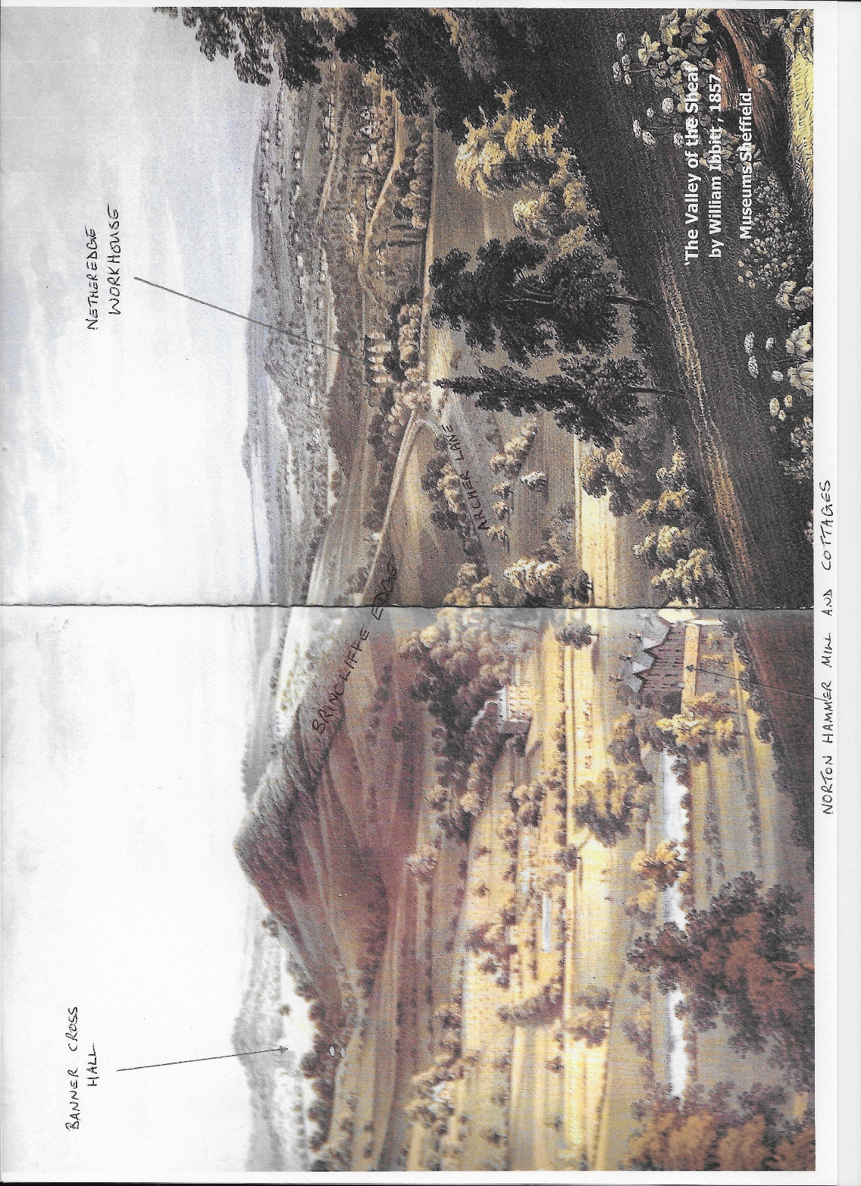
(With apologies for the poor quality) This painting was done looking north from Woodseats towards Nether Edge.
Abbeydale House is to the left of centre, with smoke issuing from one of its chimneys. Allowance must be made for artistic licence re the shape and height of Brincliffe Edge, but the picture shows how rural the whole area was in 1857.
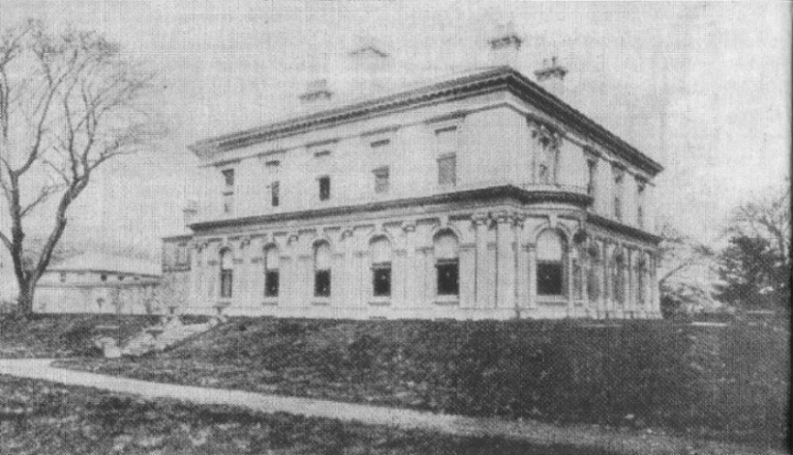
These images show the house as it would have looked shortly after construction.

When the house, with a large area of land around it, was auctioned in 1860, the auction notice was almost breathless in its praise. “First class mansion and pleasure grounds, built regardless of expense in the Italian style of architecture, situated in one of the most favourable sites in the far-framed valley of the Sheaf, commanding beautiful and extensive views over the surrounding country, which is richly wooded and highly picturesque. It described at length the various rooms: dining room, drawing room, library, boudoir, entrance hall, central hall, servants’ hall, housekeeper’s room, butler’s pantry, six bedrooms; and concluded: “Abbeydale House, in situation, character and extent, forms a most desirable residence for a family of the highest respectability and position”.
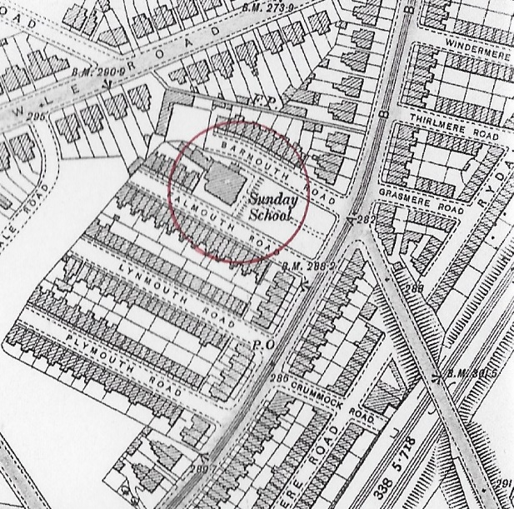

This shows the position today of Abbeydale House between Barmouth and Falmouth Roads. Woodseats Road runs diagonally from directly opposite Barmouth Road to the bottom right hand corner. The gennel marked F.P. connecting Carterknowle Road with Abbeydale Road still exists.

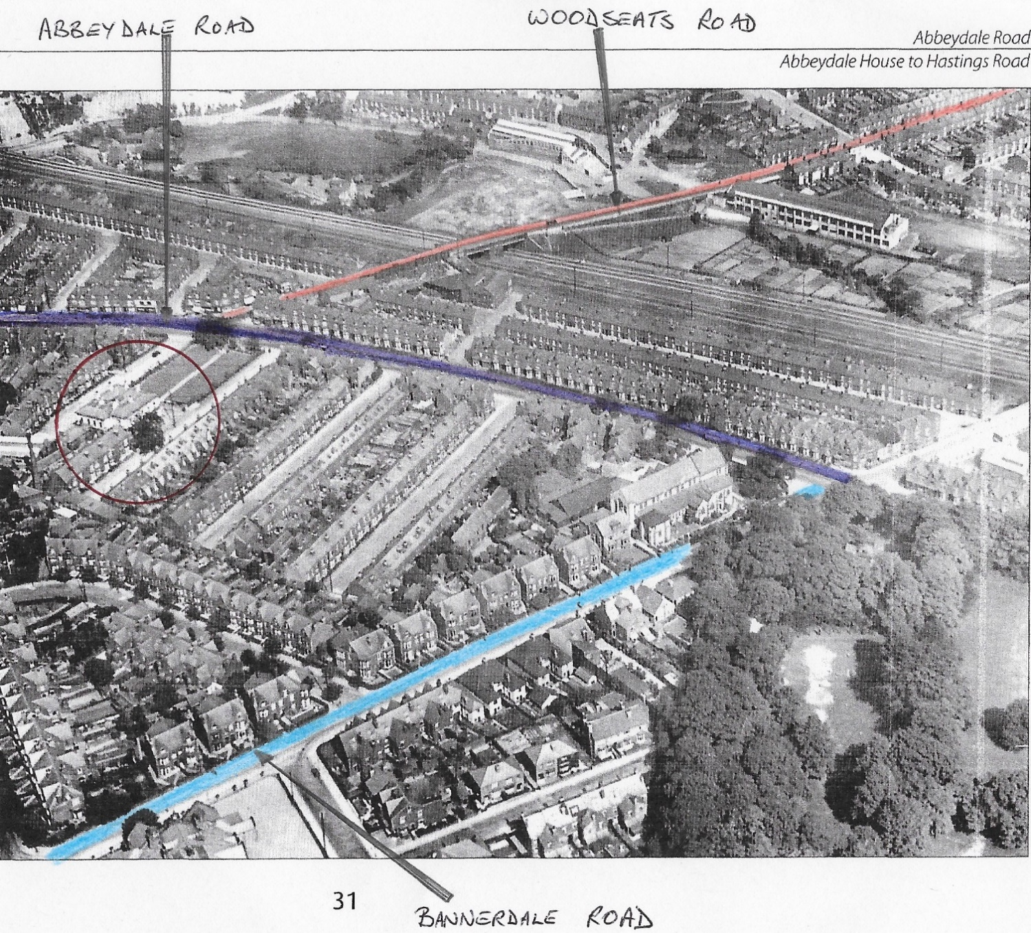
An aerial view taken in 1935. Abbeydale Road is purple, Woodseats Road orange, and Bannerdale Road blue. Abbeydale House is circled in red, and the lawns stretching down to the road were still present.
In 1875 Abbeydale House and much of the land around it was sold for £10,500 to the mayor, Mark Firth. The road built through part of this land was named after him – Firth Road. It was renamed Woodseats Road in 1903. In 1896 Abbeydale House and gardens were sold for the housing developments of Barmouth, Falmouth, Plymouth and Lynmouth Roads. Weslyan Methodists paid just £2,500 for the house itself for use as a chapel and Sunday school but before long the Circuit were showing a debt of nearly £2,000 and it was eventually sold again and between 1903 and 1906 became the offices of the Snowite Laundry.
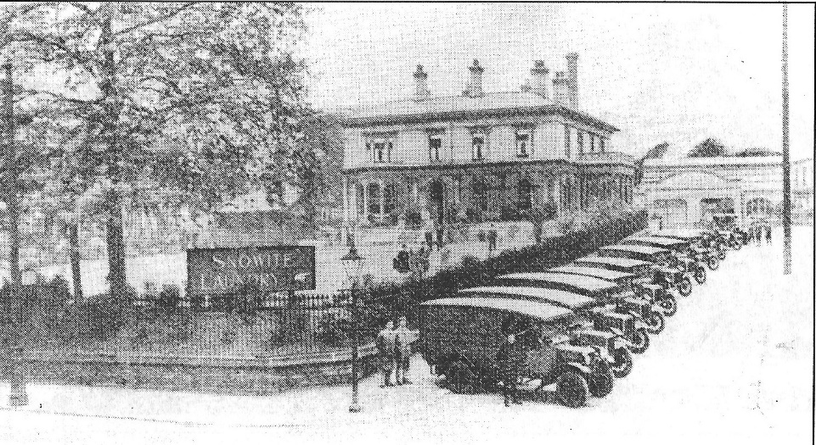
A fleet of Morris Oxford vans lined up on Barmouth Road. This picture dates from about 1929. At this time the house was the laundry’s registered offices and admin. dept., with the company boardroom on the 1st floor. The laundry itself, including a high chimney, seen here in the distance, was built behind the house.

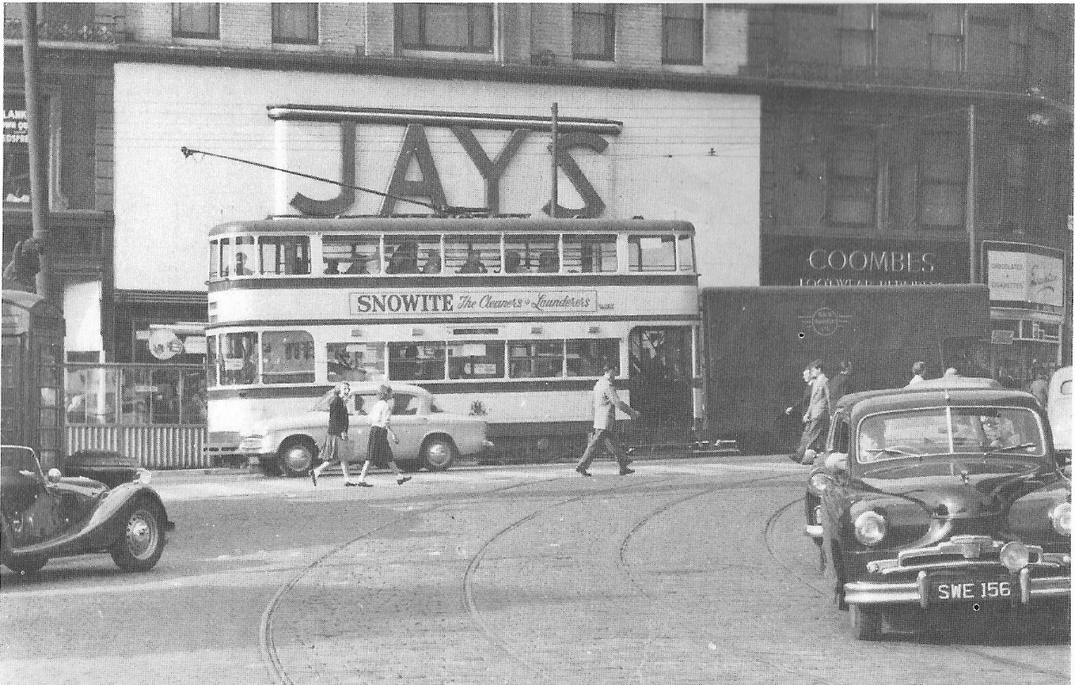
A tram outside Jays’ furniture shop at Moorhead advertising the Snowite laundry.

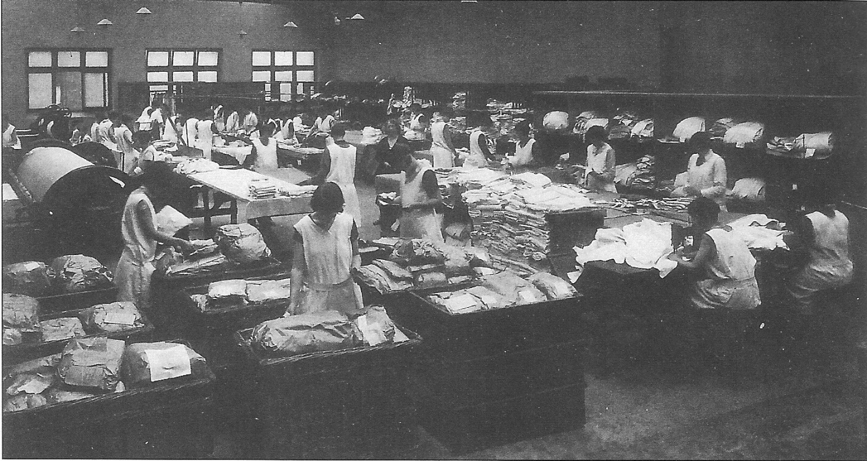
This picture from the 1930s shows Snowite’s flat pack dept., where the girls worked on sheets and pillowcases. The two ladies on the right, at sewing machines, repaired any tears in the linen. Snowite was eventually taken over by the Abbey Glen Laundry.

To be continued . . .

