Visit to the Hawley Tools Collection, at Kelham Island Museum
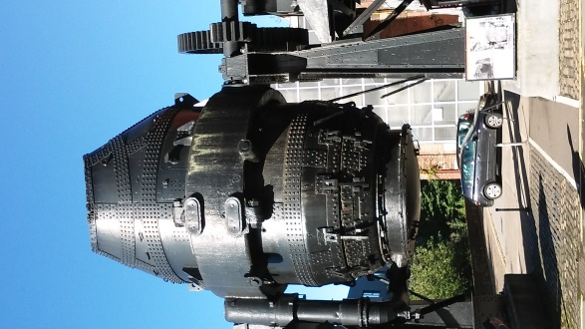
Introductory talks outside in glorious sunshine, before being split into small groups for separate tours
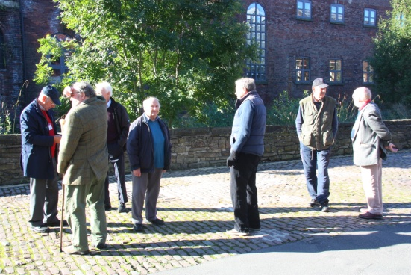
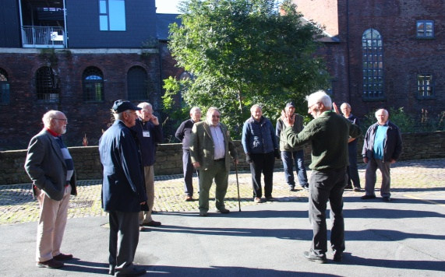
The Metrology Collection, not open to the public, is a humidity-controlled collection of precision measuring instruments, both Sheffield made and innovative designs from other parts of the world. Bench machines are seen in these two images, but we were shown specialist micrometers and Vernier gauges, including Braille versions developed in Sheffield in partnership with the RNIB

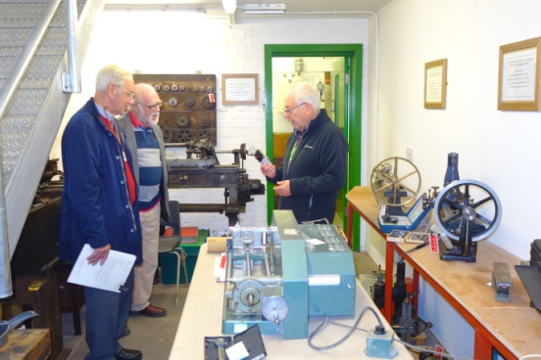

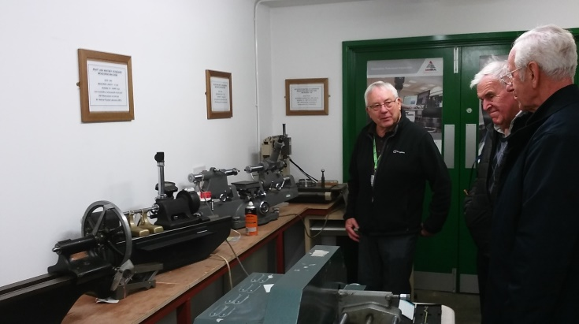

The Saw Collection contains over 2,000 saws, the oldest dated 1760
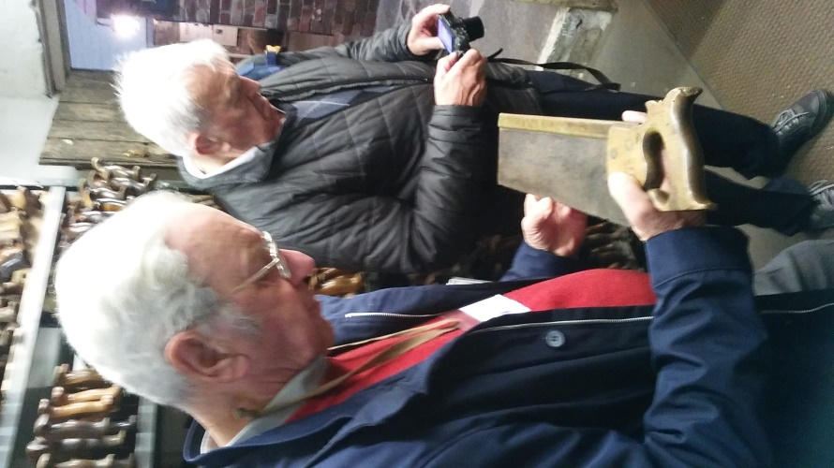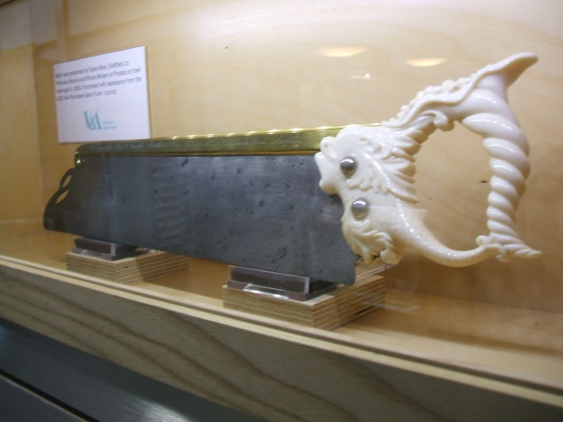
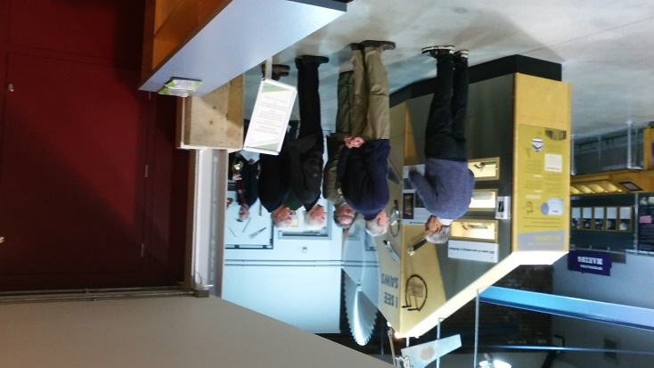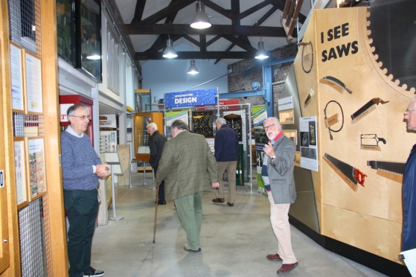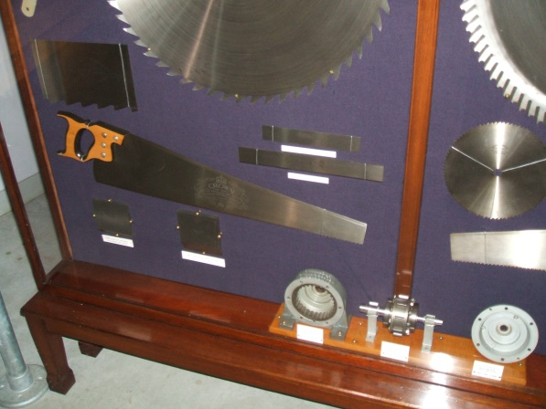

In the Edge Tool collection, the prize exhibit is the Year Knife. Made in 1822 with 1822 blades or tools, it was developed with the addition of another 178 blades to commemorate the Millennium.
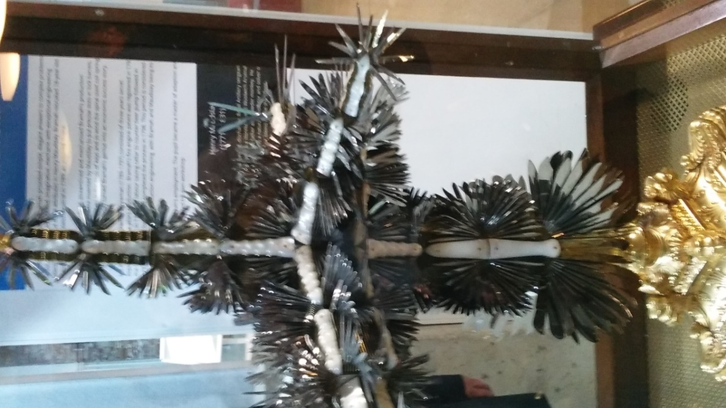
Much of the visit was’ behind the scenes’ in storerooms and wharehousing, but some of the displays caught the eye.This poster brought back memories for some (each packet contains its original blade) 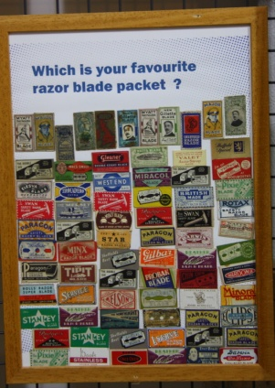 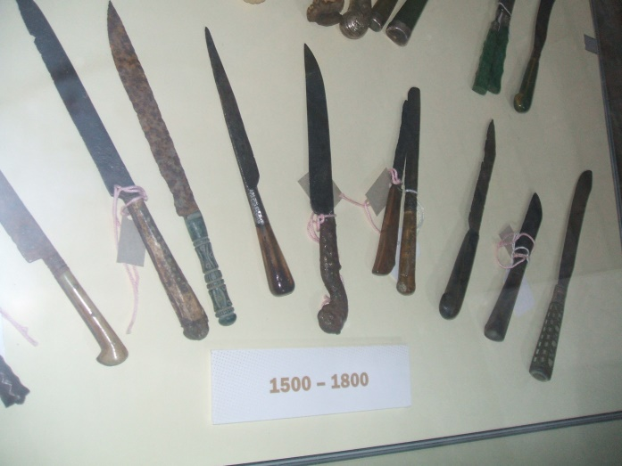
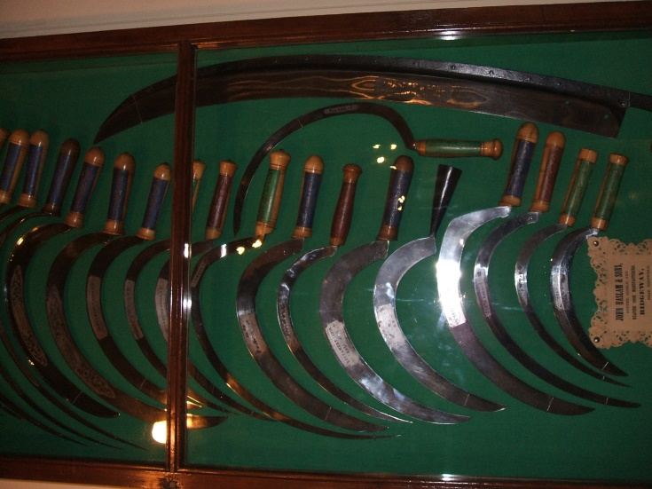

And of course, tea/coffee afterwards to complete the visit
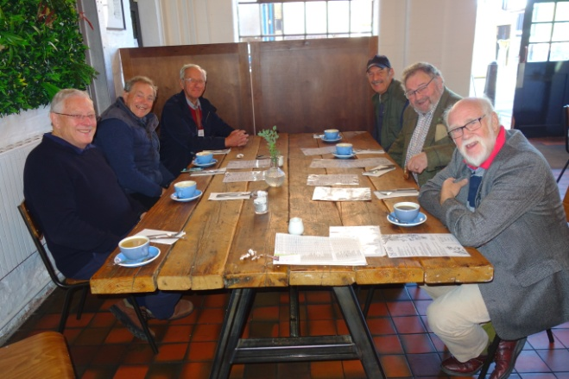

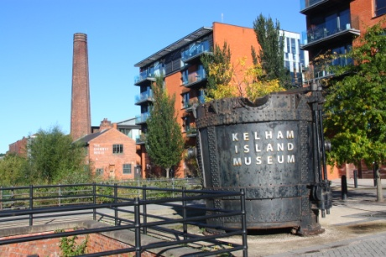

Photos taken (mostly) by Gordon Young

