My first Encounter with the BBC.
I was in the third year of my secondary schooling (in Mauritius) and had just joined a new school “Curepipe Grammar School”. The latter prided itself on having a ‘ Principal’ whose main qualification, as far as I could make out, was that he had spent about twenty years of his adult life in England.
He spoke very good English and many said that he had the gift of the gab. He was also a well dressed gentleman. He always wore an immaculate suit and also wore a scarf loosely around his neck. To complete the picture of a gentleman from England, he wore a hat, which by the way, served to hide his balding head. Most of the time, he would also wear a pair of dark sun glasses. All in all, a real dapper! He smoked a rather rare brand of tobacco called “Craven A”. I knew that, because, he would often ask me to go and fetch him a packet from the shop, during recess.
He was not my teacher of English language. However, as the Principal, he would often comment on the correct pronunciation of English words, as well as on our study of other English authors.
It so happened that during a reading/elocution contest at the school, (when I read Wordsworth’s Daffodils) I won first prize. He congratulated me and then set out to advise me, in some detail, on how to better my English diction and on the use of the English language. Among other things, he strongly advised me to listen to the British Broadcasting Corporation, the BBC, in particular to the ‘World Service’
It was almost an impossible task for me to listen to the BBC’s World Service. We had an old valve radio (Murphy), which was more of a piece of furniture than a radio set. My mother had kept a small flower vase on its top, in an attempt to embellish it. It would pick up short waves and so I was able to listen to our local radio station. When I tried to tune in, using medium and long waves, it only produced an endless buzzing sound and sometimes elements of what I thought were sounds of Morse codes. It was such a fruitless effort and I soon gave up trying to tune to the BBC.
Sometime later, I was window shopping along the main road, which for some reason we called ‘Royal Road’. I came across the window of a bookshop, which to my surprise, displayed a copy of a magazine that was entitled “The Listener” in fairly large letters and below it, appeared the letters “BBC”.
I was curious as to what this magazine could be. I went in the bookshop and when I caught the shop assistant’s eye, I asked if I could have a look at the magazine. She showed it to me and told me that it was a weekly edition, but could get from the bookshop every month.
The magazine was bigger than A4 in size and in monochrome. It was all good until she told me the price. It was five rupees a copy (then just under half a British pound). I thanked her and said I would come back to buy it or another copy once I had saved enough money.
I tried to save some of my meager spending money which my parents could afford to give me. I tried to borrow some money from of my friends, to whom I promise to circulate the magazine in return. Finally, I resorted to washing a few cars for some more money. Finally, I was able to go back to the bookshop to buy my first BBC magazine ‘The Listener’ and I was very proud to own it.
I then tried to read the magazine. I remember that it hardly made sense to me. I found that the words used in some of the articles were mostly unfamiliar to me and thus hard to fully comprehend. I had to resort to dictionary and the only one we had at home, was a ‘French to English’ dictionary- Larousse. If the English word was in the dictionary, I could find its French equivalent, but not necessarily its meaning. However, it seemed helpful. I also got to know the address of the BBC and that the Broadcasting House was at Shepherds Bush in London.
One of the articles which I found amusing, after reading it a few times, was on a radio programme, called ‘Just a minute’. I remembered the article because it mentioned the story of a schoolboy, who was told off for inattention in class and he was asked to repeat what his master had been saying for the previous minute without repetition or hesitation. I thought that was funny. Apparently, that story led to the creation of this radio comedy.
I did buy a second copy of the Listener a couple of months later. As my resources dried up, I had to abandon the idea of becoming a regular reader. I kept the two copies for a long time, until for fear of vermins, I had to bin them.
Years later, when I came to England, I made it my duty to visit the BBC, Shepherds House in London. An impressive building I thought! Once in Sheffield, as I settled at Lodge Moor Hospital Nurses Home a few days later, I bought a small radio so that I could listen to the BBC Radio, especially the World Service and the ‘Just a Minute’ programme.
It was only in 1981, that whilst campaigning for the return of the Chagos Islands to Mauritius,( which I still do to date) that I first set foot at the BBC Broadcasting House, Shepherds Bush, for a live interview on the same issue. In an aside, I told my interviewer about my past efforts to listen to the BBC World Service and to get copies of the Listener, back in Mauritius. He seemed impressed. The interview lasted five minutes. The issues were so important for me and the islanders of the Chagos, that I was not bothered to savour those five minutes of fame.
Over the years, as a result mostly of my community and voluntary work, I have become a fairly regular contributor to our BBC Radio Sheffield. In a way, it’s all thanks to my old college Principal.

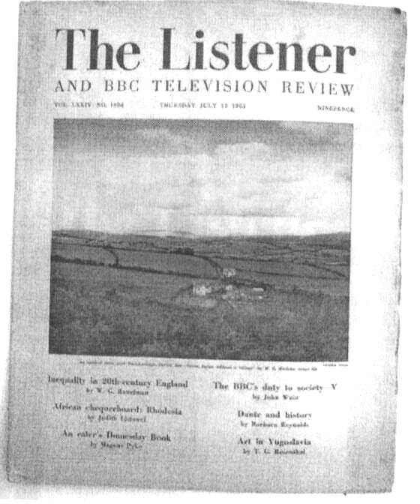A copy of an old edition of the Listener!

Ramchand Samachetty
For Probus
17 August 2020.

