C2C Part 5 Gateshead to Tynemouth
Leaving our B&B we quickly got onto the dedicated cycle route on the south side of the river Tyne. After 4 miles or so of traffic free roads and paths we made the river crossing onto the north bank via the Swing Bridge, just one of 4 bridges in the area.
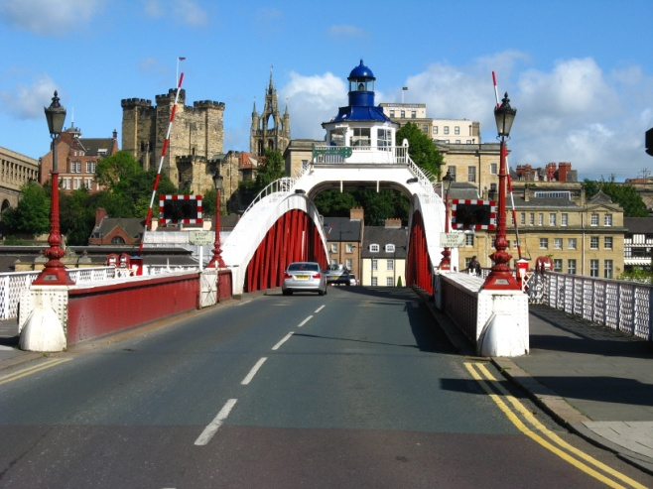 River Tyne Swing Bridge
The Swing Bridge opened in 1876 was built on the same site as the first Tyne bridge built by the Romans. The previous bridge was demolished in 1868, the current swing bridge – designed, built and paid for by William Armstrong an industrialist, whose home at nearby Cragside is well worth a visit, to allow larges boats to reach his works further up the river, was opened in 1876. At the time it was the largest swing bridge ever built and the hydraulic power to turn the bridge, installed by Armstrong, is still used today. In 1924 the bridge was rotated 6000 times, compared to the occasional use and monthly maintenance of today. A few years ago Mollie and I with our daughter had a tour and demonstration of the bridge movement and maintenance, which we found interesting.
After crossing onto the north bank we arrived at the Quays, a very popular and upmarket area with plenty of posh hotels, bars, restaurants and no doubt lively nightlife. We then follow the way mark signs directing us to Tynemouth. After just a few hundred yards we came to the Millennium Bridge which is an opening pedestrian/cycle bridge built 2001, and while we were there it opened to allow a vessel upstream. See photo
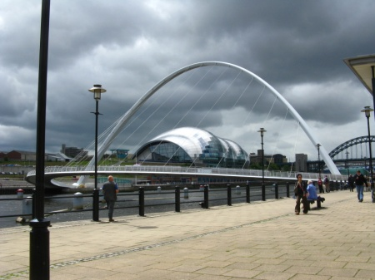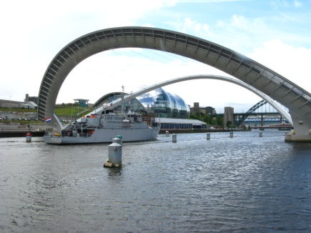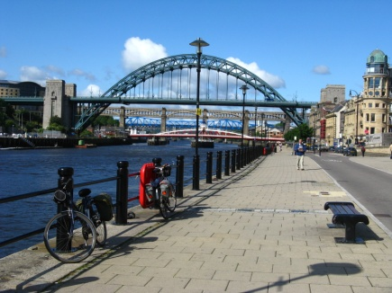
Millennium Bridge 4 Tyne bridges and Newcastle Quays
The finishing line beckoned, so onwards on the dedicated cycleway making a few slight detours inland to cross roads etc to cycle the 10 miles to Tynemouth. There were several C2C signs to make sure nobody took wrong turnings, and we arrived without any fanfares and nobody to greet us, just a few walking their dogs.
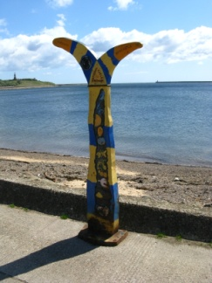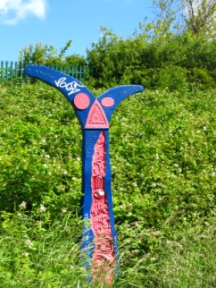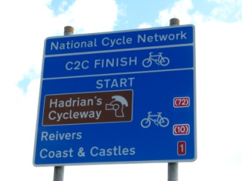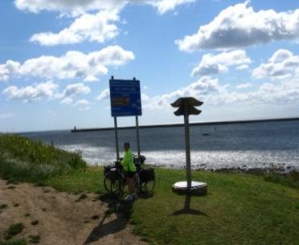
After 140 miles North Sea at last
This adventure had its ups and down, I’m sure there were more of the ‘ups’ passing through many varied and interesting places. It would be fun to redo this journey someday – but on our electric bicycles next time.

Gordon Young

