C2C Part 4 Allenheads to Gateshead
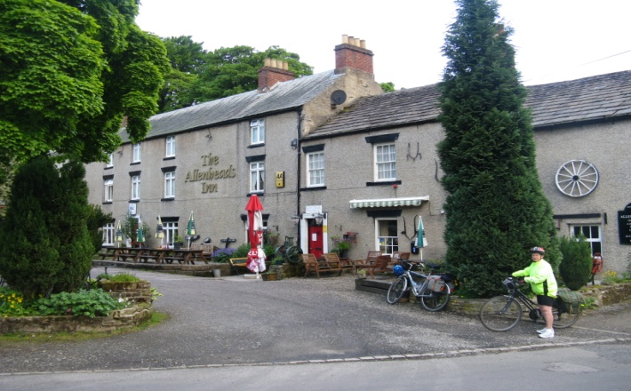
Departing Allenheads
As we were getting our gear together, the other couple cycling the C2C mentioned that it was nice to have a ‘drying room’ for the wet bikes & clothing. What drying room we asked? The management failed to mention the ‘drying room’ when we arrived the previous evening all wet and cold – another black mark for this 1 out of 10 B&B.
However we set off in dry conditions on yet another steep incline to 2000ft where we entered Durham.

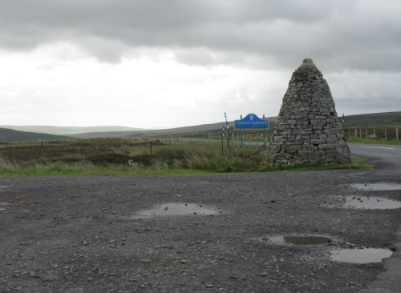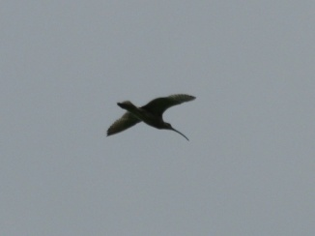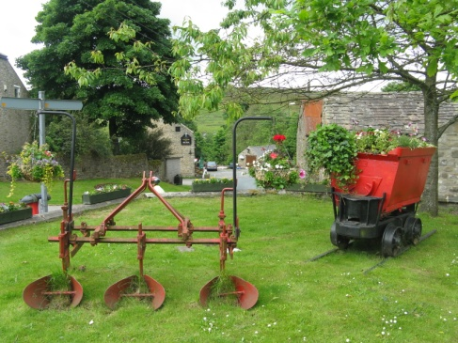
Boarder crossing into Durham curlew mining village of Rookhope
We were still in the North Pennines AONB and from the county boundary it was downhill into the upper Weardale a very quiet and lonely county where we frequently came across signs of disused mining activities dating from the 19 century. This is beautiful wild country with the scattered villages and lonely farms where the only sounds were mournful sound of the curlew and wind whistling through gaps in the walls and the infant river Wear rushing from the heather clad moors. After passing from the village of Rookhope we soon came to the larger village of Stanhope. Stanhope (pronounced stannup) is the capital of upper Weardale, means ‘stoney valley, and considered to be the centre of lead mining and an attractive village.
No time to stop – a big hill needed to be tackled before refreshments – a mile long ‘slog’ or should I say ‘push’
out of Weardale. At the point where the road joins the Waskerley Way we found the Parkhead cafe. At this junction there were magnificent views over Weardale and the Northern Pennines and the cafe lunch stop was very welcome.
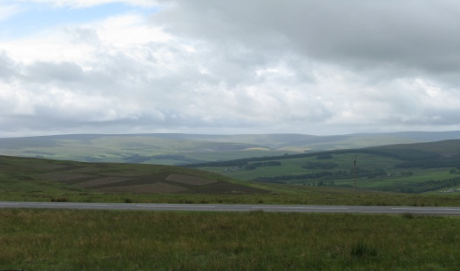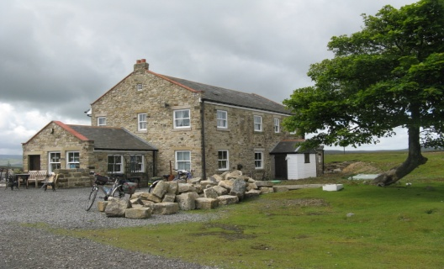
Northern Pennines Parkhead cafe
This is the start of the Waskerley way which follows the course of the western end of the former Stanhope and Tyne railway line. This early railway was opened in 1834 to transport limestone from the quarries above Stanhope and coal from various collieries to South Shields, this track was the highest mainline track (1670ft) of standard gauge and offers spendid views across Durham to the North Sea our ultimate destination.
After hte welcome lunch with great refief in that it was downhill all the way to Tynemouth. The track was very well

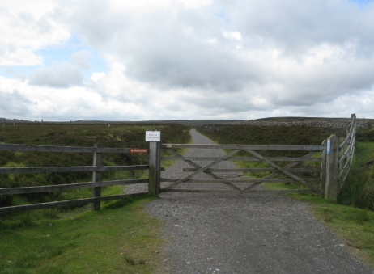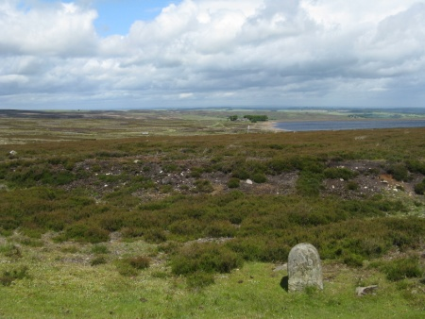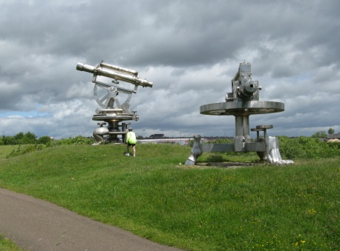
Start of Waskeley Way Smiddy Shaw reservoir & S&D waymark Terris Novalis sculptures

Constructed and the gentle slope made for easy cycling-at last! There are number of points of interest along the way Rowley station was taken down brick by brick and reassembled at Beamish Museum not too far away, Hownsgill Viaduct a 150ft high 700ft long viaduct overa dry river valley is a notable feature and a popular spot for suicde attempts hence the barriers were erected a few years ago. Towards Consett, home to Terris Novalis, there a two large stainless steel sculptures of survaying equipment created by Turner Prize winner Tony Cragg . These built on the Comsett Ironworks site and make an interesting change to the morrland scenery.
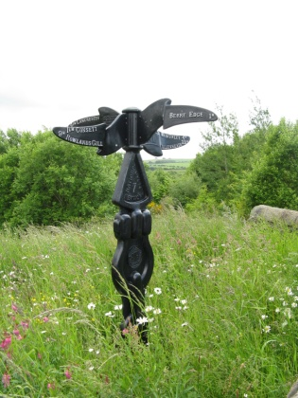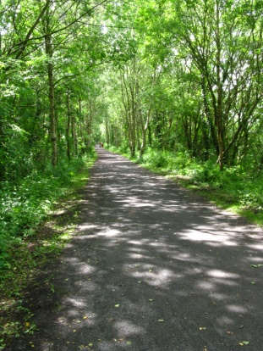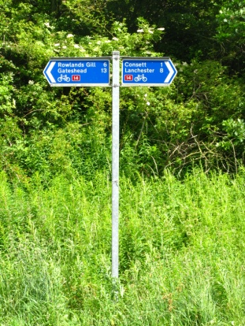
Consett to Rowlands Gill
Derwnet Walk
After negociating our way through Consett we picked up the Derwent Walk track which was a gentle ride the 4 miles to Rowlands Gill and on through Derwenthaugh Park. This led onto the busiest section of the ride so far, crossing the A1 near the Metro Centre and on to a section by the River Tyne devoted to cyclist and walkers. After a bit of searching we came to our B&B stop for the night which luckily was close to the shopping complex and where we had to make do with a less than satisfactory take away for our evening meal.
This gave us the oportunity to go into Newcastle, using our bus passes, to meet up with a friend of our eldest daughter, who very kindly treated us to a coffe and cream cake. Then back to our stay for the night where we were the only guests. The room was small but we had a good breakfast to send us on our way to the ride end at Tynemouth.

Gordon Young Gateshead to Tynemouth to be continued

