C2C Part 3 Langwathby to Allenheads
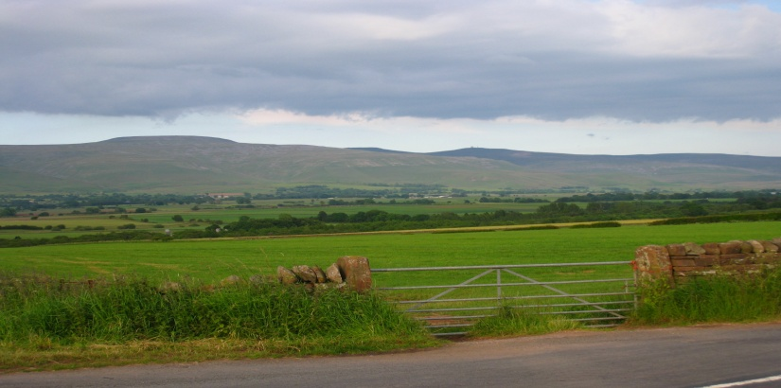
The Pennines from Langwathby. Before the rain set in.
This became the most unpleasant day of the ride. With rain threatening we set off and soon encountered the first of many steep hills – one of the highest trans - Pennine routes - Hartside Pass at 1904 ft. which is the highest point on the whole of the National Cycle network The ride started with a steady sharp incline, by this time rain had set in with a strong wind. We survived the elements and after a struggle reached the Hartside summit where we were greeted at the very welcome cafe with a hot drink and warmth where we met 2 other C2C riders, they were on E bikes!!
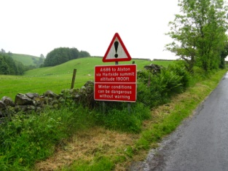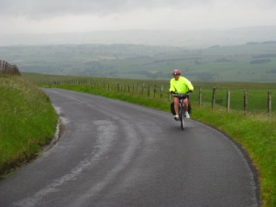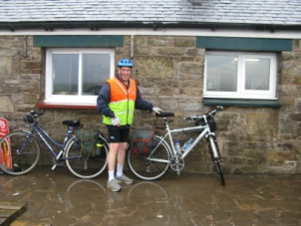
Cycling Hartside pass
The journey continued down into the South Tyne Valley, though an attractive village – Garrigill, then up a very challenging hill ( 1 in 5 gradient) to Nenthead. We found Nenthead a very unattractive and unwelcoming village, where looking for a pub lunch the first place wanted a deposit of £15 before letting us in!! The 2nd pub was open but their menu left much to be desired.
Nenthead, AT 1500ft is on old mining village, mining for lead, silver, zinc, the remains of mining are clearly visible with a visitors centre. On another day this would have been worth further investigation, but we had to press on towards Allenheads up another steep ascent to nearly 2000ft crossing the county boundary into Northumberland. This is very wild and bleak country and on a clear day the views would be tremendous.
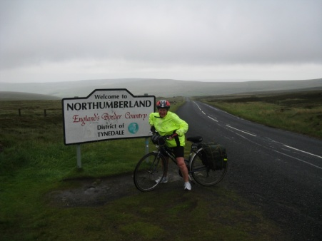
very windy entering Northumberland
We now entered the North Pennines AONB (area of outstanding natural beauty) which is the 2nd largest in UK. Leaving the very dreary Nenthead we had a very welcome few miles of downhill, still in wet conditions, towards Allendale, a very quiet area of the East and West Allen rivers, Celtic name – Valley of the Shining Water not much shining today. On reaching the valley it was uphill again to the head of the valley to Allenheads where we had booked accommodation in the local inn. Arriving wet and cold we were allocated a room ‘with a bath’ wonderful a long soak was just what was needed to warm up. On further investigation there was no bath plug! Had someone pinched it we thought, further enquiries revealed that – ‘ we don’t allow baths as being at the head of the valley if we allow baths then there is no water for the village further down the valley’ but as they were not busy the manager reluctantly let ‘borrow’ a plug. What a strange way to welcome guests! There were only 2 other guests who were also on the C2C route, and after a less that exiting evening meal after a few drinks retired for a welcome nights rest. There was another disappointment for the Youngs, to see this look at next week’s C2C instalment
Gordon Young Allenheads to Gateshead - to be continued

