C2C (Sea to Sea) a cycling adventure (part 1)
Whitehaven to Keswick
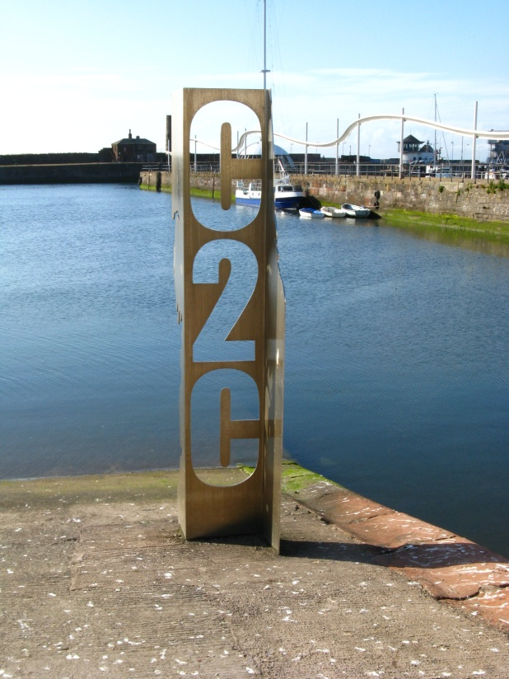
The C2C cycle ride is a long distance route from the Irish Sea to North Sea, not to be confused with the Wainwight walk – coast to coast. This is a 140 mile route from Whitehaven to Tynemouth (there are alternative to the start and finish points – Workington or St Bees to Sunderland), using the National Cycle network of over 12700 miles
In 2010 my wife, Mollie, and I cycled this route over 4 days and 2 x half days and raised over £1700 for charity, staying in B&B accommodation using the official guide in selecting places to stay. Using our campervan we stayed on a farm site near Cleater Moor, after cycling to the start (picture above) and using an old railway track returned to the van for the first nights stay. This track was the old Whitehaven-Cleater-Egremont railway which served many iron mines in the area. This line opened 1857, closed to passengers in 1866 and finally closed completely 1960.
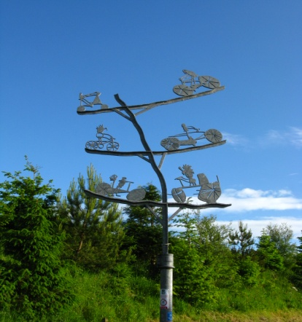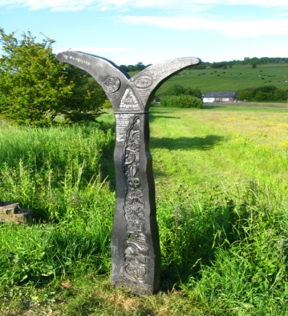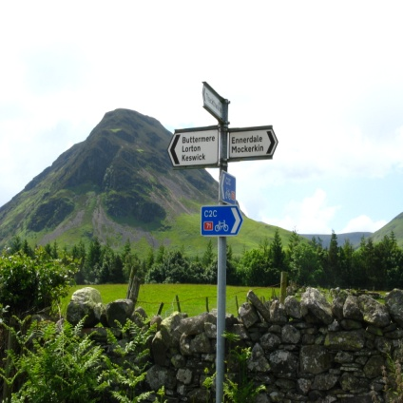
Interesting signs on this track, 2nd sign is one of over 1000 erected all over the country on the many long distance cycle routes. These are all roughly the same shape and shows distances to the marked way although the colouring of these sign changes from area to area. The way is well signed with the C2C logo
The following day we set off to Keswick, our next stay, using quiet lanes, passing Ennerdale Bridge, Loweswater, and the Lorton valley revelling in the mountain scenery before a wakeup call in tackling our first big hill climb to the Whinlatter Pass.(1043ft), where there is a visitors centre and an adventure playground. After using the refreshment facilities we had a glorious downhill ride into the Newlands valley, through Braithwaite into the busy town of Keswick with its lovely Derwentwater setting. We eventually found our stay, tucked away in one of the many back street and we were not disappointed with the accommodation. There are numerous pubs and restaurants available which we made use of and some very welcoming liquid refreshment.

Gordon Young Keswick to Langwathby To be continued

