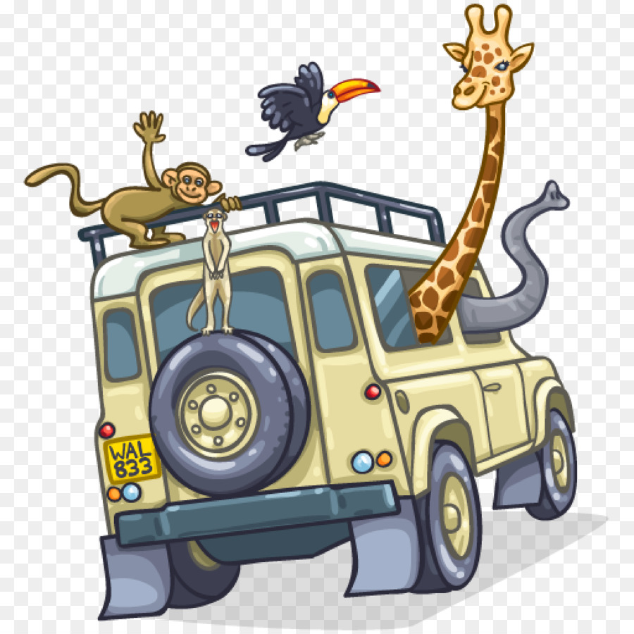
3

FIRST STEPS IN GYNAECOLOGY

Herewith a suggestion that might be a useful to a young medical student starting out in a gynaecology career.. If he or she is faced with a mother who is well overdue, the following short personal anecdote might offer a possible solution.

Two years after leaving school I was living forty miles up country in a forestry camp on the border between what used to be called the French Cameroons and the British Cameroons. One dark night, in the middle of a heavy tropical downpour I was woken up and asked if I could take a very heavily pregnant wife to the nearest missionary hospital in Duala.

So with dad to be, mother in law, me in the front of my long wheelbase Land Rover and expectant mum and at least half a dozen local midwives/supporters in the back, we set of on the forty mile trip to Duala on a very bumpy, bush road.

A sheltered background and the curriculum of a typical English public school had not prepared me for what was to follow. I desperately tried to avoid the worst of the bumps but each one that we hit produced blood curdling screams from the back with continuous wailing providing the chorus. Father to be and mother in law provided a different chorus urging me to go faster and faster.

After one particularly vertiginous bump the yells, wailing and shouting came to a halt with a series of heavy bangs on the back of the cab accompanied by even higher pitched screams and what I now realise were cries of encouragement in the local dialect by the chorus in the back of my Landie. Then came the announcement that baby had arrived and to prove the point one of the chorus came round to my window with this exceedingly new baby wrapped in swaddling clothes. It was then agreed that a return back to the camp was in order and excitement levels began to subside a little only to reach a crescendo when dawn found us back where we had all started from in the pitch dark some hours before. The reception for the new baby, dad, mum, the birthing party and me was memorable in a way that could only happen in Africa. Dancing drumming, ulalating and singing that would have put Glastonbury to shame.

Some few days later I was sitting in my bungalow enjoying a sundowner, listening to the BBC Overseas Service on my treasured Bush radio when my steward announced that there was a gathering of locals waiting to see me outside. I was very surprised and delighted to see a group of colourful and smiling local women. Centre piece was the new baby, looking decidedly more respectable than the last time that I had seen him. I was presented with loads of local vegetables, three chickens and a large calabash of palm wine!

Then came the formal side of the ceremony. In a mixture of pidgin english and patois french the group’s spokesman announced that the new arrival’s name was to be Richard Inyang Bassey. I was very touched.

So when next you are taking a stroll through the tropical rain forests of West Africa and you meet a local aged about sixty and named Richard, please remember me to him.

Richard Lowe
Sept 2020

